Sub Queries : SINGLE ROW SUB QUERY , MULTI ROW SUB QUERY

It is an example for one of the nested query.

To write sub query also we need at least one common column.

Unnecessarily if we use joins, it decreases the performance Of query.

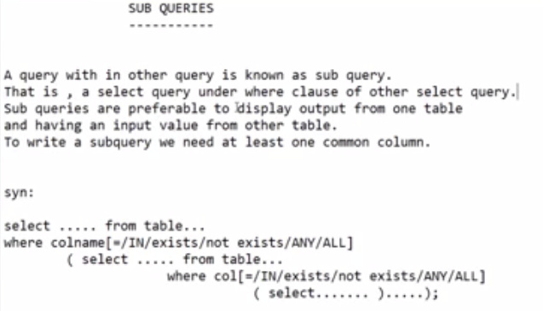

SINGLE ROW SUB QUERY

SQL> --get dept name of emp id 7654

SQL> select dname from dept where deptno=

2 (select deptno from emp where empno=7654);

DNAME

--------------

SALES

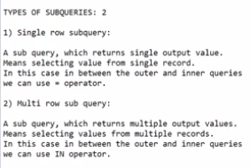



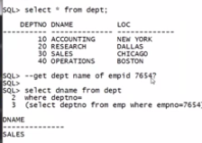

SQL> select ename from emp where deptno=

2 (select deptno from dept where dname='ACCOUNTING');

ENAME

----------

KING

CLARK

MILLER

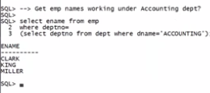

--MULTI ROW SUB QUERY

SQL> --get dept details of emps SMITH , SCOTT

SQL> select \* from dept where deptno in (select deptno from emp where ename in ('SMITH', 'SCOTT'));

DEPTNO DNAME LOC MANAGER

---------- -------------- ------------- ----------

20 RESEARCH DALLAS

SQL> select \* from dept where deptno in (select deptno from emp where ename in ('SMITH', 'MARTIN'));

DEPTNO DNAME LOC MANAGER

---------- -------------- ------------- ----------

20 RESEARCH DALLAS

30 SALES CHICAGO

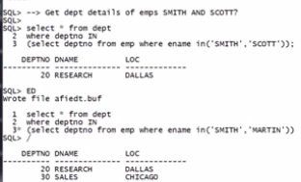

SQL> -- GET EMP DETAILS FROM DEPT SALES ?

SQL> SELECT \* FROM EMP WHERE DEPTNO=(SELECT DEPTNO FROM DEPT WHERE DNAME='SALES');

EMPNO ENAME JOB MGR HIREDATE SAL COMM

---------- ---------- --------- ---------- --------- ---------- ----------

DEPTNO

----------

7698 BLAKE MANAGER 7839 01-MAY-81 2850

30

7499 ALLEN SALESMAN 7698 20-FEB-81 1600 300

30

7521 WARD SALESMAN 7698 22-FEB-81 1250 500

30

EMPNO ENAME JOB MGR HIREDATE SAL COMM

---------- ---------- --------- ---------- --------- ---------- ----------

DEPTNO

----------

7654 MARTIN SALESMAN 7698 28-SEP-81 1250 1400

30

7844 TURNER SALESMAN 7698 08-SEP-81 1500 0

30

7900 JAMES CLERK 7698 03-DEC-81 950

30

6 rows selected.

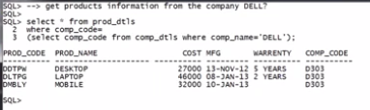

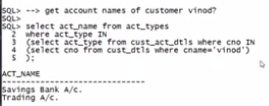

--EXAPLES COMBINING SUB QUERIES AND JOINS

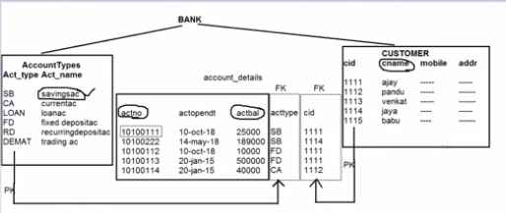

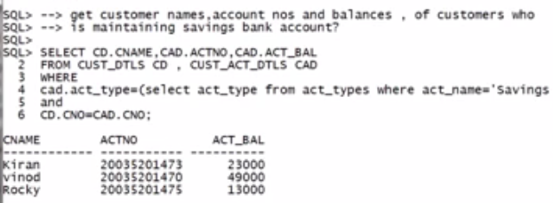

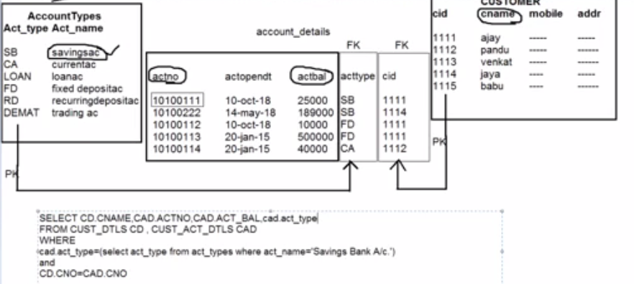

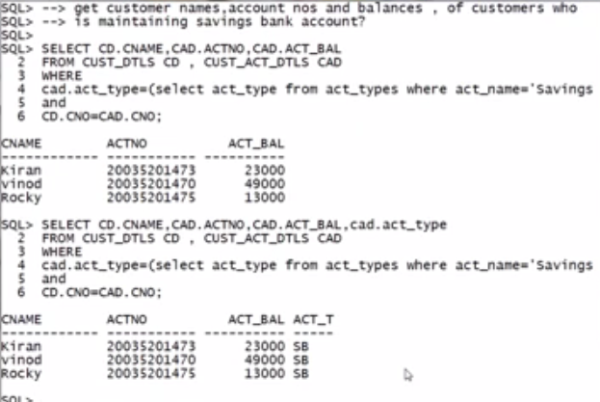

PRACTICE BELOW EXAMPLES

